**CHAPTER I**

**INTRODUCTION**

By the annual statistics of Energy of “CENTRAL STATISTICS OFFICE MINISTRY OF STATISTICS AND PROGRAMME IMPLEMENTATION GOVERNMENT OF INDIA NEW DELHI”

* Compound Annual Growth Rate (CAGR) of Production of Coal & Lignite in 2017-18 over 2008-09 are 3.20% & 3.62% respectively whereas their consumption grew at 5.01% and 70% respectively during the same period.
* In case of Crude Oil and Natural Gas, during the period 2008-09 to 2017-18 the Production increased by 0.63% and (-) 0.06% whereas Consumption increased by 4.59% & 4.82%.
* During the aforesaid period, Generation of Electricity increased by 5.71 %and Consumption of electricity increased by 7.39%.

Yardstick of a nation’s progress today. It keeps the injudicious exploitation of energy in check, thereby reducing the gap between the ordinary and the privileged. The existence and need of energy measurement precede the actual onset of electricity consumption. In early 1870s, the time when gas lamps were the most popular source of energy, there existed gas meters to compute the energy consumed. Since then, the energy calibration process has come a long way. Edison’s electrochemical meter for measuring DC didn’t gain much popularity as it was labour-intensive to read.

The currently available meters use the operating principle first implemented in Blathy’s meters in 1889. Today’s conventional meters use kilowatt-hour as the standard unit of measurement. The billing requires readings to be read once during the period. This creates room for error as it involves human intervention.

Over an era, consumers are complaining about the display of false reading and thus getting the meter replaced. The process of gathering data takes enormous manpower cost. Therefore, development in this field has to provide energy efficient meter with more features. In order to deduct errors in calculating the cost of power consumption we are designing enhanced energy meter which scales down human disruption. The advancement to present meter is Smart Energy Meter which computes consumption of electrical energy in an enhanced manner when compared to conventional electromechanical meters. Therefore, consumer can check his/her energy consumption details from internet. Hence, the consumer understands their electricity usage patterns and so can modify their behaviour to lessen their energy usage profile. The aim of our given system is to design very low cost WiFi-based single phase digital energy meter with IoTs concepts.

**CHAPTER II**

**PROJECT OVERVIEW**

In this project designing and building smart energy meter, the aim is to provide awareness to consumer that power consumption and load circuit is measured using Arduino Programming sketch. The load circuit is consisting of resistive, inductive and capacitive or combination of above.

The current flowing circuit is used to measure the suitable technique and its signal given to Arduino board. Power is being measured using Arduino programming sketch and it is also used to measure other quantities such as power factor, active and reactive power etc. and everything is displayed to LCD.

Power of DC circuit and purely resistive AC circuit power is product of voltage and current and reactive AC current is called as apparent power (VA).

Arduino is an open source single board microcontroller and it provided as open source, writing platform design to make the process of using electronics in multidisciplinary project. Arduino is flexible and easy understanding hardware cum software in our project we have used Arduino Uno microcontroller based on the Atmega 328.

**2.1 BACKGROUND OF ELECTRICITY METER**

**Evolution of Electricity Meters from the Past**

In early years, electricity is available only to a specific section of affluent society. The advancement in technology over time encouraged meeting the demands of common people in all parts of the world. The history of electricity meter is well connected involving researchers from past. The general usage of electricity in the early 1870‘s is only confined to telegraphs and arc lamps. With the invention of the electric bulb by Thomas Elva Edison, the power energy market became widely opened to the public in the year 1879. Oliver B. Shallenberger introduced his AC ampere hour meter in the year 1888. Eventually, the progressive development in metering technology leads in enlightening the lives of many common people.

**Traditional Electricity Meters and its types**

The electrical devices that can detect and display energy in the form of readings are termed as electricity meter. Traditional meters are used since the late 19th century [21]. They exchange data between electronic devices in a computerized environment for both electricity production and distribution. In most of the traditional electricity meter aluminum discs are used to find the usage of power. Today ‘s electricity meter is digitally operated but still has some limitations. A simple 1 Phase 2 Wire electricity meter is shown in the below figure



Fig 2.1 “Traditional meter”

Some of the limitations faced by the traditional electricity meter are as follows:

* Meters are unreliable in nature as consumer has to anticipate for the monthly electricity bill.
* The process of measurement is supported by a specific mechanical structure and hence they are called as electromechanical meters.
* In order to perform meter readings, a great number of inspectors have to be employ-ed.
* Payment processing is expensive and time consuming.
* New type of tariffs on hourly basis cannot be introduced with the corresponding meters for encouraging the consumer.
* Development of meter software applications and supportive network infrastructure is complicated.

Besides the above-mentioned limitations, there are also several other elements creating a huge gap between the consumer and distributor because of installation of traditional meters.

**CHAPTER III**

**LITERATURE SURVEY**

Bibek Kanti Barman et al. have developed an IOT Based Smart Energy Meter for Efficient Energy Utilization in Smart Grid using WiFi module (ESP 8266 12E), Optocoupler 4N35, ACS712 current sensor. The proposed device basically works by Controlling load from board through relay and drivers and controlling through IOT interface achieving energy analyzation and detecting power theft [1]. In [2], Prathik.M et al. have developed a Smart Energy Meter Surveillance Using Arduino NodeMCU (esp8266), GSM Module (SIM 900), voltage sensors and current sensors. The proposed device basically works by giving the data of energy consumed on daily basis, its corresponding rupees, billing details and payment using IoT achieving daily report of consumption and also automatic shutdown or starting the service. Himanshu K. Patel, et al. have developed a Arduino Based Smart Energy Meter using GSM. They used aurdino uno, LDR(light dependent resistor) and DS1307 RTC(Real Time Clock). The proposed device basically works by giving the update on energy consumption along with final bill generation along with the freedom of load re-configuration achieving Good interface between consumer and electricity provider through electricity meter and automatic cutoff of service[3] . In [4]Sri Krishna Sankalp Gunturi, et.al have developed an IoT based Domestic Energy Monitoring Device using Microcontroller(MSP430F6736),wifi module(ESP 8266). The proposed device basically works by monitoring the kWh consumption patterns of the the desired appliance and appliance energy consumption for the required amount of time achieving direct result of machine watt consumption.

Karthikeyan et al. have developed an IoT Based Real-Time Residential Energy Meter Monitoring System using optical sensor and aurdino NodeMCU(ESP 8266). The proposed device basically works by Server based control system interfacing in mobile through telegram app achieving Interface through public app telegram command reply system [5]. In [6]Rahul Rajesh B et al. have developed an IoT Based Automatic Energing Sysyem with Prepaid/Postpaid Configurability using ARM controller(Cortex M4) and WiFi module(CC3100). The proposed device basically works by controlling load as well as input watt from supply line and giving the power cut alert and tampering alert achieving controlled power (watt) supply postpaid as well as prepaid in same meter. Saikat Saha et al. have developed IoT Based Smart Energy Meter using Arduino UNO, Wi-Fi module (ESP8266-01), current transformer (CT), potential transformer (PT), voltage regulator (AMS1117). The proposed device basically works by providing the energy usage information to the user in through the internet achieving high accuracy and real time values[7]. Jai Krishna Mishra et al. have developed an IoT Based Smart Energy Management System using Raspberry Pi, Light Sensor (TCS3200), Channel Relay, Arduino. It basically works as Electronic Meter Automation Device (EMAD) which can be mounted on an old meter which was done by embedded chips working on raspberry pi achieving Server as well as webpage interface load control[8].

Osmi Jaiswal et al. have developed an Arduino Mega and IOT based Intelligent Energy Meter (IEM) to Increase Efficiency and Accuracy in Current Billing Methodology using Arduino Mega 2560, Ethernet shield, NOT Gate (7404 IC), GSM Shield (SIM 900), Relay. It basically works because of Arduino which continuously monitors and sends the data to base station on web server using Ethernet Shield and power of unpaid consumers would be disconnected using a relay which would be controlled wirelessly using the concept of Internet of things achieving Server controlled meters and Online current billing and least manpower[9]. In [10]Nazmat Toyin Surajudeen-Bakinde et al. have developed a Internet Based Prepaid Energy Meter using Arduino (AT89S52), potential and current sensor, WIFI module(ESP 8266), server cloud. It basically works by allowing consumers to have access to monitor and control their consumption achieving Prepaid energy meter and automatic turnoff of power supply. Win Hlaing et al. have developed a WiFi-Based Single Phase Smart Meter for IoT using Arduino, WiFi module (ESP8266), potential and current sensor, GSM module. It basically works by automatically reading the unit and sending the data automatically for the power users to view their current energy consumption, this system has got real time outputs and are highly accurate [11].

**CHAPTER IV**

**Power and Power Measurement**

**4.1 Power-**

Power means rate of expanding energy. The unit of power is watt (joule per second j/s ). In DC circuit and purely resistive AC circuit power is product of voltage and current. For reactive AC circuit the product of r.m.s values voltage and r.m.s value of current is called apparent power (VA). The potential difference in volts between two points is equal to the energy per unit charge (in joules/coulomb) which is required to move electric charge between the points since the electric current measure the charge per unit time (in coulomb/second). The electric power P is given by the product of the current I and the voltage V (in joule/sec = watts).



Where,

Q=electric charge in coulombs

t=time in sec.

I=electrical current in ampere

V=electrical potential or voltage in volts.

**4.1.1 DC Circuit Power-**

In a dc circuit if VL is the voltage supped to load and IL is the load current ten the dc load power is given by the product of the load supply voltage VL and the load current IL thus,

Pdc = VL IL watt

If RL is the resistance of the load than,





**4.1.2 AC Circuit Power-**

In alternating current circuit due to energy storage element such as inductance and capacitance may result in periodic reversals of the direction of energy flow.

thus,





Then the average power given by,



This gives the average power consumption in a.c. circuit as,



Where,

V = r.m.s. value of the voltage=Vm/√2

I = r.m.s. value of the current=Im/√2

Cosφ = power factor of circuit

Φ = power factor angle=V^I

**4.1.3 Active Power**–

The production of power flow that avarage over a complate cycle of the ac waveform result is net transfor of energy is one cycle is known as real power (active power ) it is power consumed by the resistive element in the circuit active power is the power that is actualy being consume by the load.

**4.1.4 Reactive Power–**

The portion of the power flow due to storage element that return to the source in each cycle is known as reactive power When the voltage and current are perodic with same functional frequency. the instantaneous power is also perodic with twice the functional frequency.

**4.1.5 Avarage Power-**

Average power is defined as energy transfer rate average over many peroid of the lowest frequncy in signal. It is also defined as average amount of workdone or energy converted per unit of time, if Δ𝜔 is the amount of work performed during a period of time Δ𝑡.

The average power Pavg over the period is given by the formula

Pavg=Δ𝜔/Δ𝑡

**4.1.6 Instantaneous Power-**

The instantaneous power is than the limiting value of average power as the time interval Δ𝑡 approaches zero.

P=Limit→ avg

Electric power is generally developed by electric generator but can also be supplied by chemical source such as electric battery. Electric power generally supplied to businesses and home by the electric power energy.

**4.2 Power Measurement-**

We measure power is both type of circuit AC as well as DC. Power is measured by following techniques.

1. Using measuring device and

2. Using software by interfacing the circuits

**4.2.1 Power measurement using various measuring equipment-** Power is product of voltage and current so we measure voltage and current for measurement of power.

**4.2.1.1 Using voltmeter and ammeter-**



Fig 4.1 “Power Measurement-1”

Consider the circuit using voltage and ammeter for the measurement of power, as shown in fig 4.1

The ammeter measures the load current Il and there is voltage drop Va=IlRa across the ammeter where Ra is the ammeter resistance.

⸫ VL = V - Va

⸫ PDC = VLIL = (V – VA)IL

⸫ Pdc = VIL – VAIL

Where,

VIL = Power measured by the meters

Pdc = Power consumed by load.

VA IL = Power consumed by ammeter.

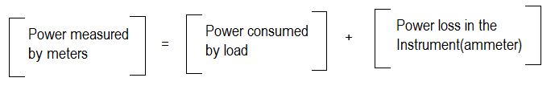

Hence the product of ammeter and voltmeter does not give correct power consumed by the load.

If the voltmeter is shifted across the load to measure the load voltage, the circuit becomes as shown in the Fig.

Now as voltmeter is across the load, it measure VL correctly but ammeter measures current I which is sum of IL and IV.

I = IL + IV

⸫Pdc = VL IL = VL (I – IV ) = IVL - VLIV

Where,

IVL = Power measured by meters

Pdc = Power consumed by load

VLIV = Power consumed by voltmeter



Fig 4.2. “Power Measurement-2”



This by any method, the power measured is higher than the power actually consumed by the load. The power loss in the instrument near the load causes the error.

**4.2.1.2 Using wattmeter**

**4.2.1.2.1 Dynamometer**

A dynamometer can measure power in both DC and AC systems. A dynamometer has two coils: static coil and movable coil. It uses the interaction between the magnetic fields produced by the currents in two coils or sets of coils to measure power. Torque is proportional product of current in current coil and current in voltage coil. The Accuracy of dynamometer is nearly 0.25 %.



Fig 4.3. “Electrodynamometer Wattmeter”

**4.2.1.2.2 Digital wattmeter (up to 100 kHz)–**

A modern digital electronic wattmeter/energy meter samples the voltage and current thousands of times a second. For each sample, the voltage is multiplied by the current at the same instant; the average over at least one cycle is the real power. A computer circuit uses the sampled values to calculate RMS voltage, RMS current, VA, power (watts), power factor, and kilowatt-hours. The readings may be displayed on the device, retained to provide a log and calculate averages, or transmitted to other equipment for further use.

**Advantages of digital wattmeter-**

* High Resolution
* High Accuracy

**4.2.1.2.3 Power Triangle Method –**

Real and reactive powers can also be calculated directly from the apparent power, when the current and voltage are both sinusoids with a known phase angle θ between them:



Fig 4.4. “Power Triangle”

(Apparent power)2 = (real power)2+ (Reactive power)2

Real power = (apparent power)*(cosØ)

Reactive power = (apparent power)*(sinØ)

**4.2.3 Power measurement using software-**

**A. Power measurement using Multisim:**

17 In Multisim power can be measured using various methods like 1-wattmeter method, 2-wattmeter method, 3-wattmeter method. One such method is discussed in detail here.

Two wattmeter method: In this method power is measured for three phase balanced loads using two wattmeter. The total power consumed is calculated using the below formula.

Total Power Consumed, Wtotal= √3*(W1+ W2)

Where,

W1 – first wattmeter reading

W2 – second wattmeter reading

Let us consider a three phase circuit having resistive balanced loads. Connect the circuit in multisim and the total power calculated is 900watts using the above formula. Simulation circuit of 2-wattmeter method power measurement in multisim.



Fig 4.5. “Power measurement using Multisim”

**B. Power measurement using Labview:**

Power measurement can also be done using Labview software. Labview is a system design platform and development environment for a visual programming language. Labview ties the creation of user interfaces (called front panels) into the development cycle. Labview programs/subroutines are called virtual instruments (VIs).

The graphical approach also allows non-programmers to build programs by dragging and dropping virtual representations of lab equipment with which they are already familiar. For a three-phase system, a single-phase wattmeter can be connected in each phase. Using this three-wattmeter configuration, the total real power can be obtained by adding the three wattmeter readings.

Total power consumed, P = P1 + P2+ P3

Where,

P1- wattmeter reading first phase

P2- wattmeter reading second phase

P3- wattmeter reading third phase

**4.3 Power factor –**

The ratio between real power and apparent power in a circuit is a called the power factor it is a practical measure of the efficiency of a power distribution system.

For example if two system transmitting transfer equal amount of real power, if one transmitting system have lower power factor so higher circulating current due to energy to the source from energy storage in the load due to higher current its produced higher losses and efficiency of transmission line is decrease and a lower power factor circuit subjected to higher apparent power and higher losses for equal or same value of real power.

When voltage and current waveform are in a phase than power factor is unity and when current leads or lags to the voltage by 90 degree when power factor is zero. Basically power factor state as ‗leading‘ or ‗lagging‘ to show the sign of phase angle of current with respect to voltage.

In purely capacitive circuit supply is reactive power so current lead the voltage by 90 degree which purely inductive circuits property of inductance is absorb reactive power so current waveform lagging to the voltage waveform by 90 degree.

That means if capacitor and inductance connected in single circuit that cancel out effect of each other.

When the system waveform is purely sinusoidal the power factor is the cosine of the phase angle between the I V sinusoidal waveform.

**CHAPTER V**

**SYSTEM ARCHITECTUREs**

The model which is used in present is time consuming and it needs a lot of labor. The proposed device will record the kWh consumption patterns of the specific appliance which we desire to keep the record. The proposed device is compact in size and light weighted when compared to regular single-phase domestic meter. It will send the data to cloud when connected to Wi-Fi router. It is a very low-cost Wi-Fi based single phase based digital energy meter. These features are implemented using the Arduino, NodeMCU (esp8266) micro controller, voltage and current sensors. The proposed system eliminates the need of labor and it is a cost efficient and a time saving process and also the electricity usage can be monitored from a remote area. It gives the data about the energy consumption on daily basis, billing through IoT.

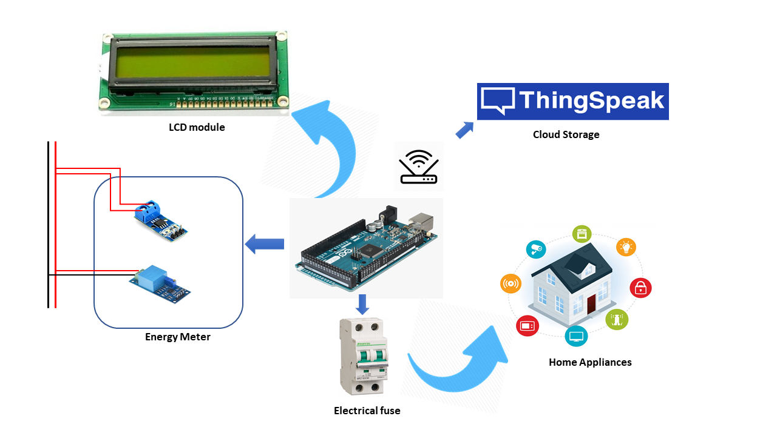

Fig 5.1 “Block Diagram”

**5.1 Hardware Requirements**

|  |  |  |
| --- | --- | --- |
| Sr. no | Name of components | Model name |
| 1 | Arduino | ATMEGA328 |
| 2 | Voltage sensor | ZMPT101B |
| 3 | Current sensor | ACS712 |
| 4 | LCD display | 16*2 |
| 5 | WIFI module | ESP8266-01 |

Table 5.1 “Hardware Requirements”

**5.2 Hardware Specification**

* **Arduino**: - It is an ATmega 2560 based micro-controller. In the given system it acts as the main control unit. Arduino Mega is one of the microcontrollers from the Arduino family which is specially designed for projects with more storage space and complex circuitry. The micro-controller is incorporated with 54 digital pins, 16 analog pins, 16 MHz frequency of crystal oscillator. As it comes with a greater number of pins, it is convenient to embed various parametric sensors of both digital and analog nature in large IoT based devices. The microcontroller used here comes handy with Arduino IDE software and also can work with other operating systems like RTX and FreeRTOS.

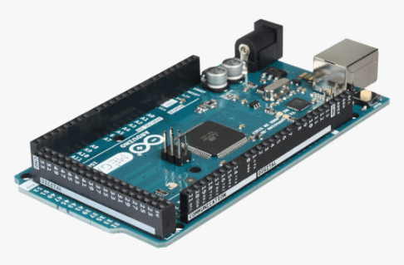

Fig 5.2 “Arduino Mega Board”

* **Voltage Sensor**: - The single phase voltage sensor unit is ZMPT101B ultra micro voltage transformer with supply voltage of 5VDC, signal output of analog and small size with high accuracy, good consistency for voltage and power measurement. The sensor module voltage has 250VAC AC maximum signal from an analog signal module. It can be connected to the microcontroller's ADC pin used immediately as Vref + 5V Arduino Microcontroller.

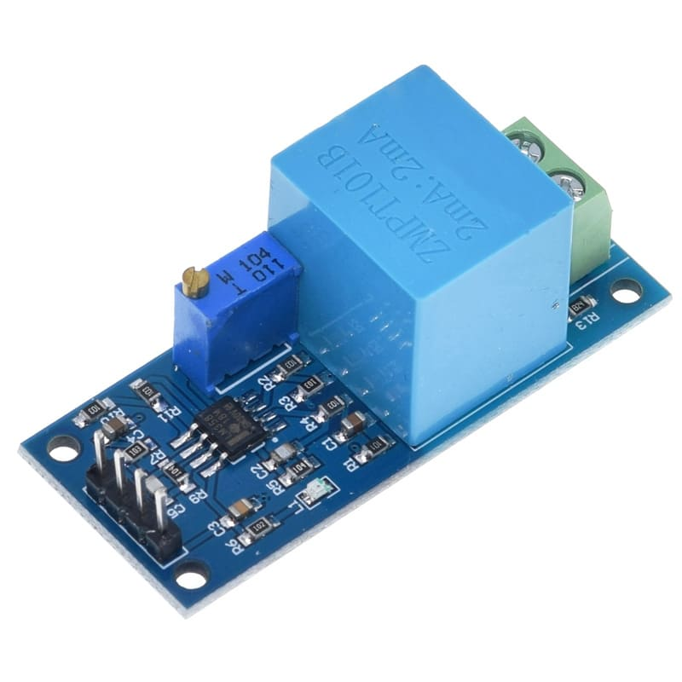

Fig 5.3. “ZMPT101B Voltage Sensor”

* **Current sensor**: - The current sensor of the meter is able to operate with the maximum of 30 Ampere, and it is designed to be easily used with micro controllers, like the Arduino. This current sensor device ACS712 can provide very low-cost solutions for AC current sensing for communication systems. This device package allows for easy implementation, especially the applications include load detection and management, switching-mode power supplies, and over current fault protection.

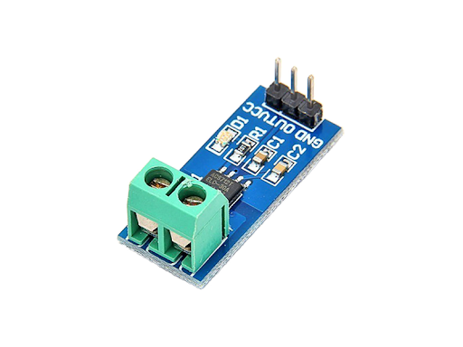

Fig 5.4. “ACS712 Current Sensor”

* **LCD**: - A liquid crystal display is used in the system for displaying the voltage value, current sensor value, units and price. A 16*2 electronic display is a low-cost optical device with 16 pins. It has 32 characters with each character of 5*8-pixel dots. An interface IC (HD44780) is mounted on the LCD module to get command data from MCU.

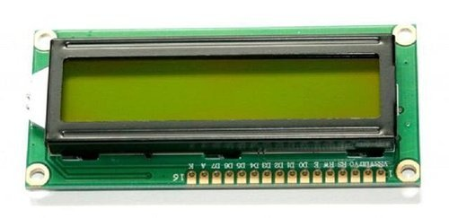

Fig 5.5. “16*2 LCD Display”

* **WIFI module**: - The ESP 8266 Wi-Fi module is a low-cost component with which manufacturers are making wirelessly networkable microcontroller module. ESP 8266 Wi-Fi module is a system-on-a-chip with capabilities for 2.4GHz range. It employs a 32-bit RISC CPU running at 80 MHz. It is based on the TCP/IP (Transfer control protocol) [3]. It is the most important component in the system as it performs the IOT operation. It has 64 kb boot ROM, 64 kb instruction RAM, 96 kb data RAM.

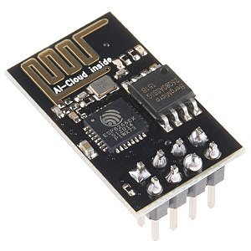

Fig. 5.6 “Esp8266 Wi-Fi Module”

**5.3 Software Requirements**

**A] Arduino IDE**

Arduino IDE is an open source software that is mainly used for writing and compiling the code into the Arduino Module. It is an official Arduino software, making code compilation too easy that even a common person with no prior technical knowledge can get their feet wet with the learning process. It is easily available for operating systems like MAC, Windows, Linux and runs on the Java Platform that comes with inbuilt functions and commands that play a vital role for debugging, editing and compiling the code in the environment.

A range of Arduino modules available including Arduino Uno, Arduino Mega, Arduino Leonardo, Arduino micro and many more. Each of them contains a microcontroller on the board that is actually programmed and accepts the information in the form of code. The main code, also known as a sketch, created on the IDE platform will ultimately generate a Hex File which is then transferred and uploaded in the controller on the board. The IDE environment mainly contains two basic parts: Editor and Compiler where former is used for writing the required code and later is used for compiling and uploading the code into the given Arduino Module. This environment supports both C and C++ languages.

**B] IoT platform ThingSpeak**

The Internet of Things(IoT) is a system of ‘connected things’. The things generally comprise of an embedded operating system and an ability to communicate with the internet or with the neighboring things. One of the key elements of a generic IoT system that bridges the various ‘things’ is an IoT service. An interesting implication from the ‘things’ comprising the IoT systems is that the things by themselves cannot do anything. At a bare minimum, they should have an ability to connect to other ‘things’. But the real power of IoT is harnessed when the things connect to a ‘service’ either directly or via other ‘things’. In such systems, the service plays the role of an invisible manager by providing capabilities ranging from simple data collection and monitoring to complex data analytics.

ThingSpeak is a platform providing various services exclusively targeted for building IoT applications. It offers the capabilities of real-time data collection, visualizing the collected data in the form of charts, ability to create plugins and apps for collaborating with web services, social network and other APIs. We will consider each of these features in detail below.

The core element of ThingSpeak is a ‘ThingSpeak Channel’. A channel stores the data that we send to ThingSpeak and comprises of the below elements:

* 8 fields for storing data of any type - These can be used to store the data from a sensor or from an embedded device.
* 3 location fields - Can be used to store the latitude, longitude and the elevation. These are very useful for tracking a moving device.
* 1 status field - A short message to describe the data stored in the channel.

**CHAPTER VI**

**SYSTEM IMPLEMENTATION**

**6.1 Hardware Implementation**

In our IoTs proposed system, the Ardunio Mega module is the center processing unit of the system and responsible for communication between the digital energy meter and gateway web server in order to read the meter parameters and display at the LCD and web server for the power management system. There are two main parts in our system implementation design, the first one is the digital energy meter with embedded ESP8266 WiFi module and the second one is the gateway web server for power management system. The architecture of our proposed digital meter with WiFi module is shown in Fig

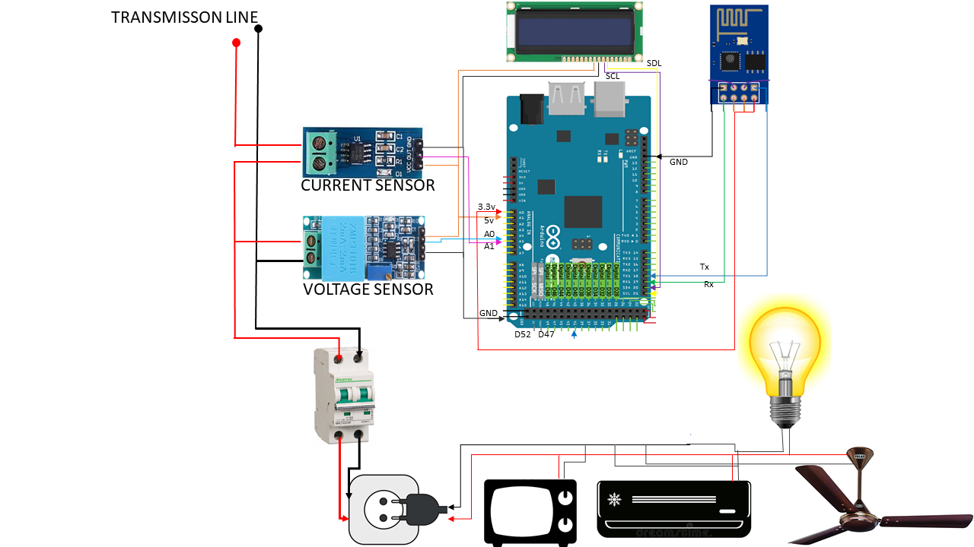

Fig 6.1. “Circuit Diagram”

In our proposed system, the digital energy meter consists of Arduino Mega which is the main function for calculating the meter parameter such as current, voltage, power in kW. The current sensor of the meter is able to operate with the maximum of 30 Ampere, and it is designed to be easily used with micro controllers, like the Arduino. This current sensor device ACS712 can provide very low-cost solutions for AC current sensing for communication systems. It is connected to analog-pin of Ardunio Mega. This device package allows for easy implementation, especially the applications include load detection and management, switching-mode power supplies, and over current fault protection. The single phase voltage sensor unit is ZMPT 101B ultra micro voltage transformer with supply voltage of 5VDC, signal output of analog and small size with high accuracy, good consistency for voltage and power measurement. It is also connected to analog-pin of Ardunio Mega. The sensor module voltage has 250VAC maximum signal from an analog signal module. It can be connected to the microcontroller's ADC pin used immediately as Vref + 5V Arduino Mega. The 16x2 LCD display module can describe 16 characters in 2-line display with black text on the green background. The LCD has two registers for command and data. It is easily programmable with no limitation of displaying.

The ESP8266 Wi-Fi is a very low-cost Wi-Fi chip module which produced by Shanghai-based Chinese manufacturer, Espressif Systems, is a free-standing system on a chip with integrated TCP/IP protocol stack that can give any microcontroller access to Wi-Fi network. The ESP8266 can function not only for hosting an application but also as offloading all Wi-Fi networking functions from another application processor. With pre-programmed with AT command, ESP8266 module set firmware; it can simply hook this up to Arduino device for Wi-Fi connection. Wifi module uploads the calculated data to the Iot platform server THINGSPEAK, where the data is represented in graphical manner to the consumer. Following figure shows the model of the energy meter

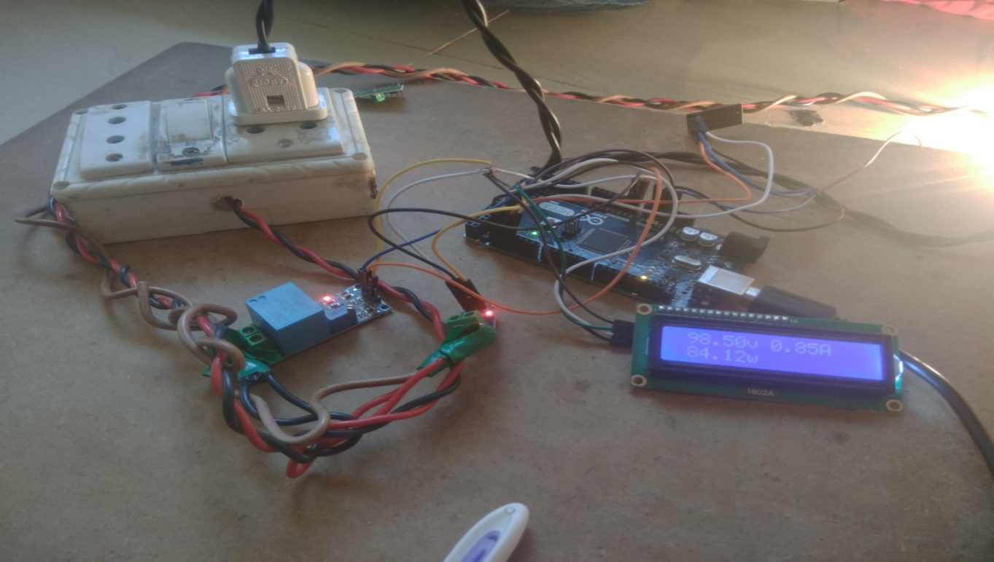

Fig 6.2. Model of electricity meter

**6.2 Workflow**

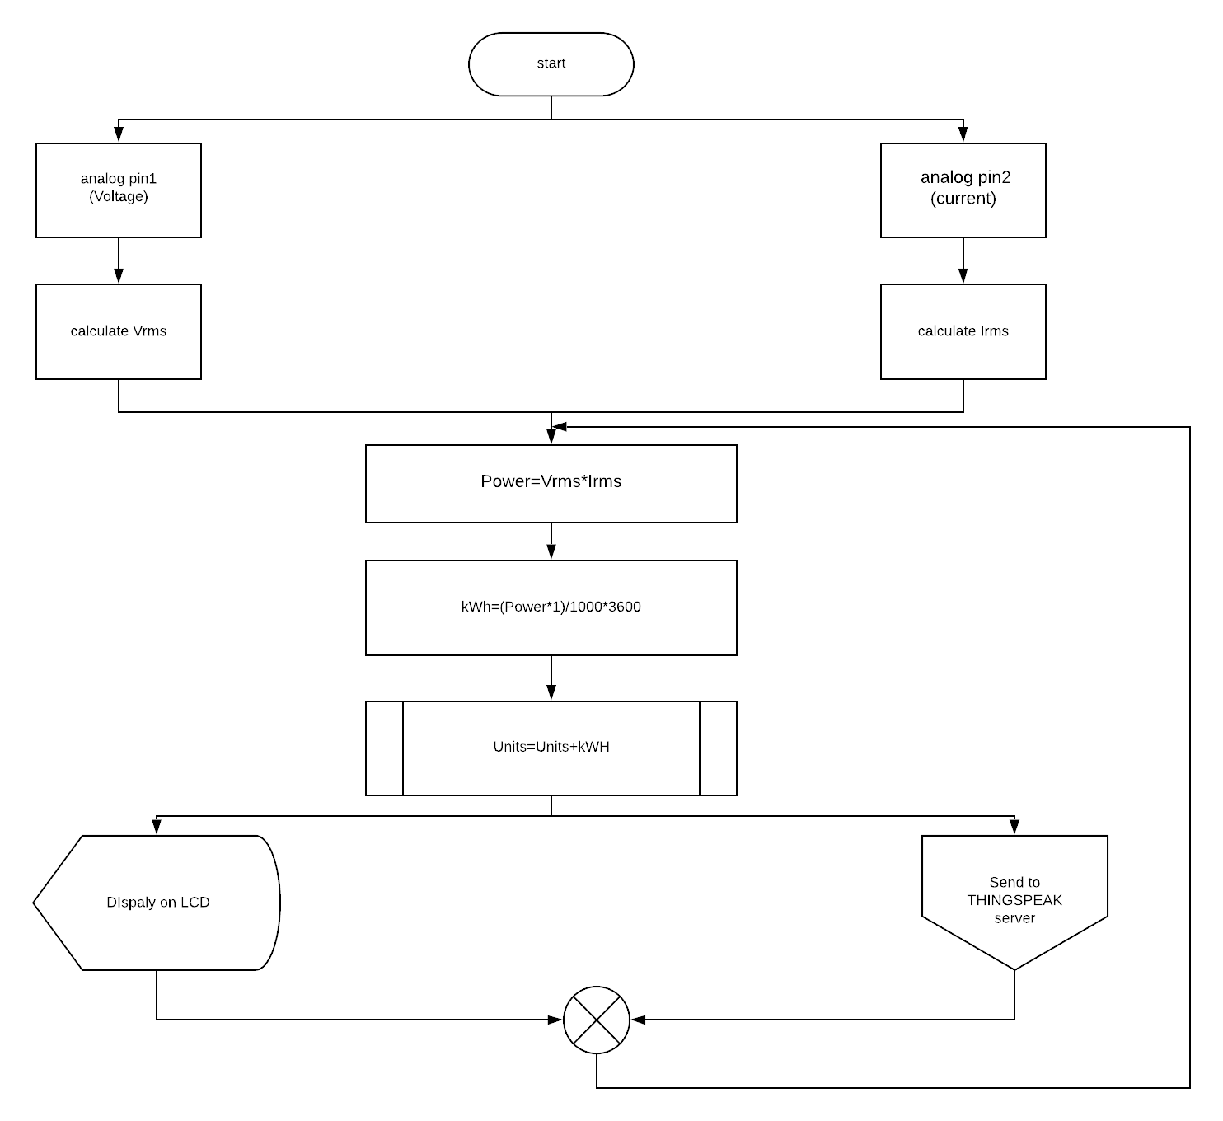

Fig 6.3. “Flowchart of the electricity meter”

Wifi module continually uploads the Units calculated by the Arduino processor to the THINGSPEAK server. LCD also displays the values of all parameters and makes the at place interface for the consumers. Thingspeak server shows all the parameters in graphical manner so that the consumer can analyse its uses easily.

**CHAPTER VII**

**RESULTS AND DISCUSSION**

**7.1 Results**

After the installation of the energy meter to the household single phase, we took down the reading over every parameters of the energy calculation on the two different loads.

**7.1.1 Results of the serial monitor of Arduino IDE**

1. Over 0W load

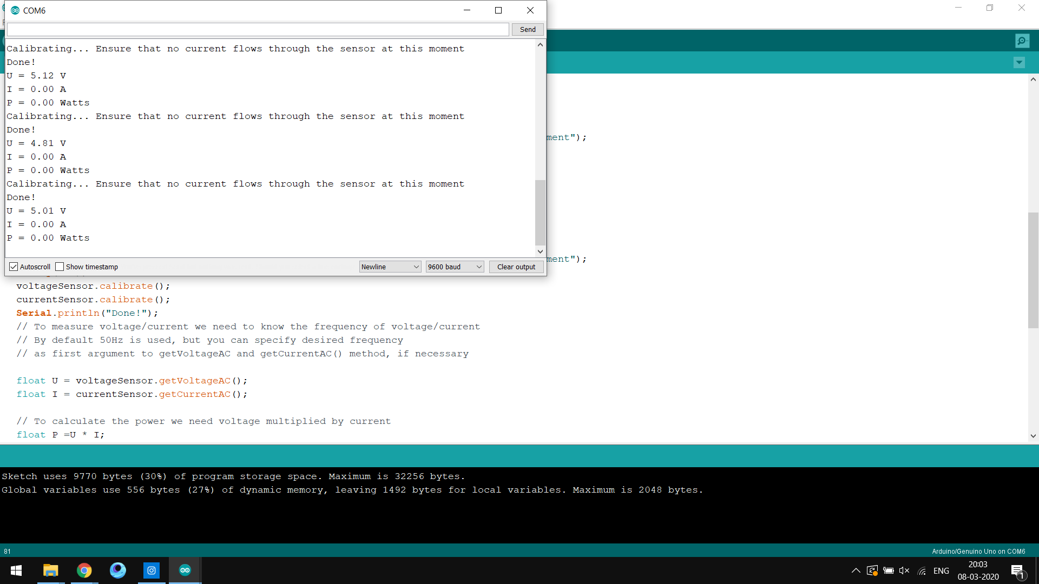

Fig 7.1. “Result of 0W load”

1. Over 100 load

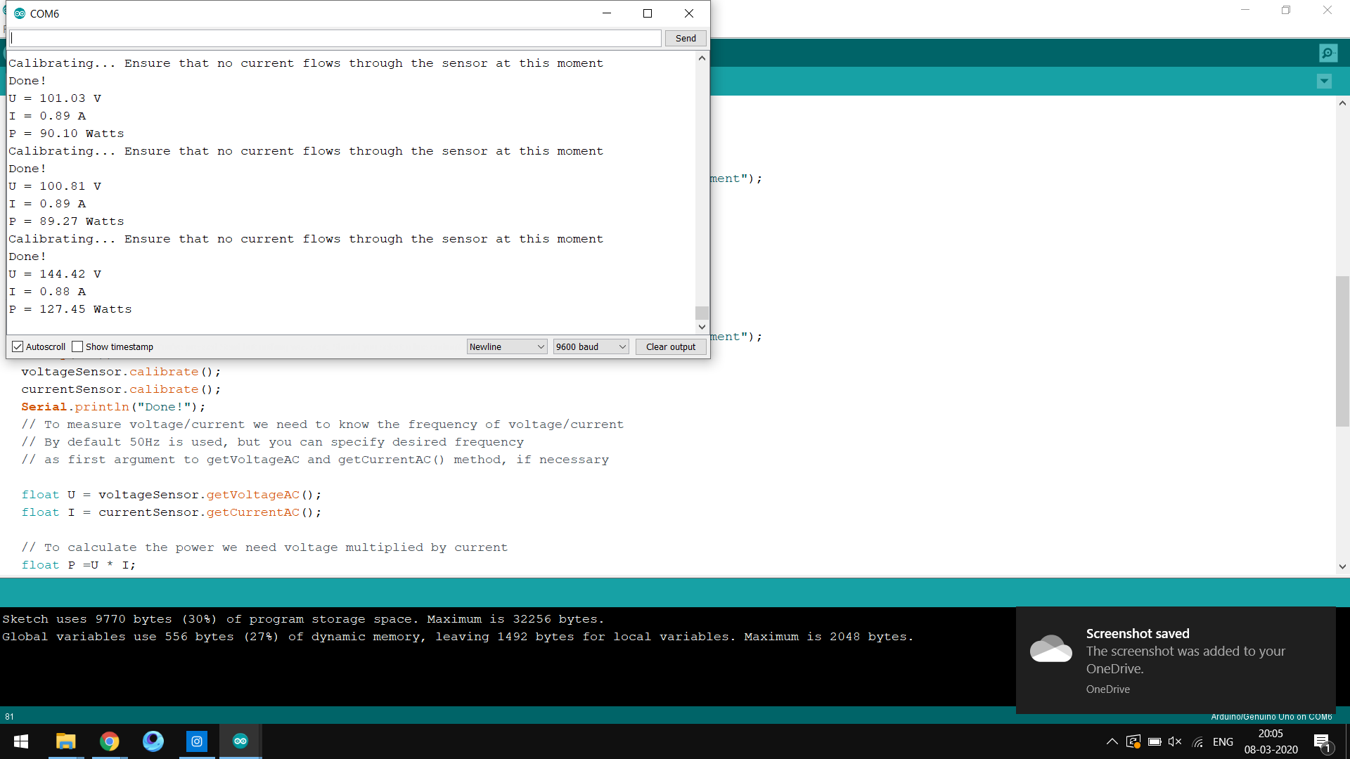

Fig. 7.2. “Result of 100W load”

* + 1. **Results of the IoT platform THINGSPEAK**

1. Voltage

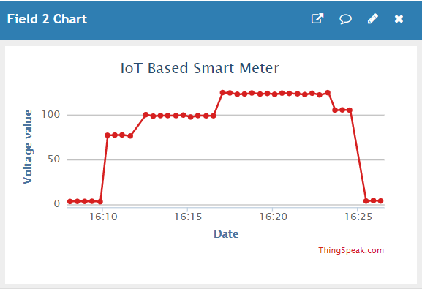

Fig 7.3. “Voltage Values”

1. Current

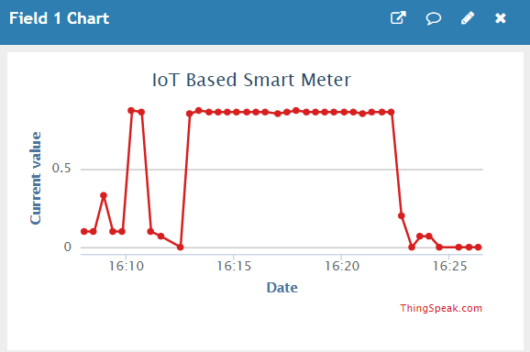

Fig 7.4. “Current Values”

1. Power

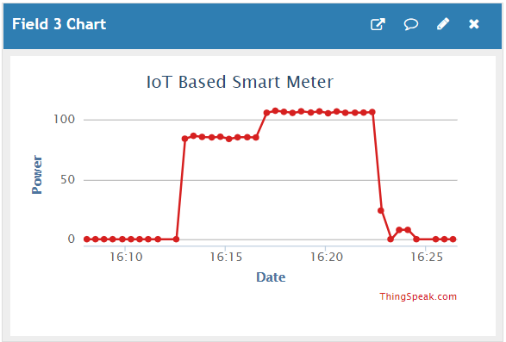

Fig. 7.5. “Power Consumed”

1. Units consumed

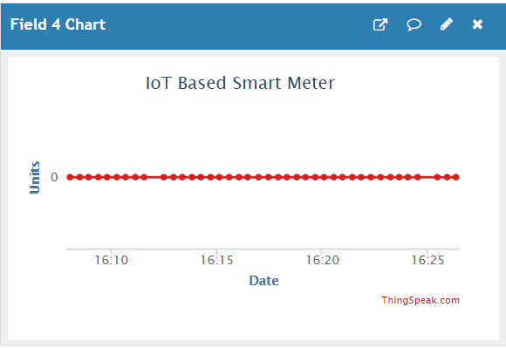

Fig 7.6. “Units Consumed”

1. Rupees

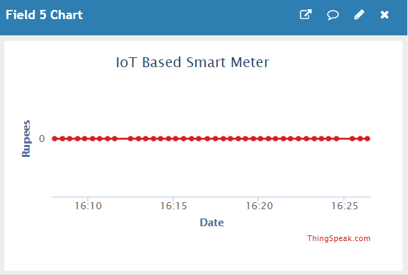

Fig 7.7. “Charged rupees”

* + 1. **Results on the LCD**

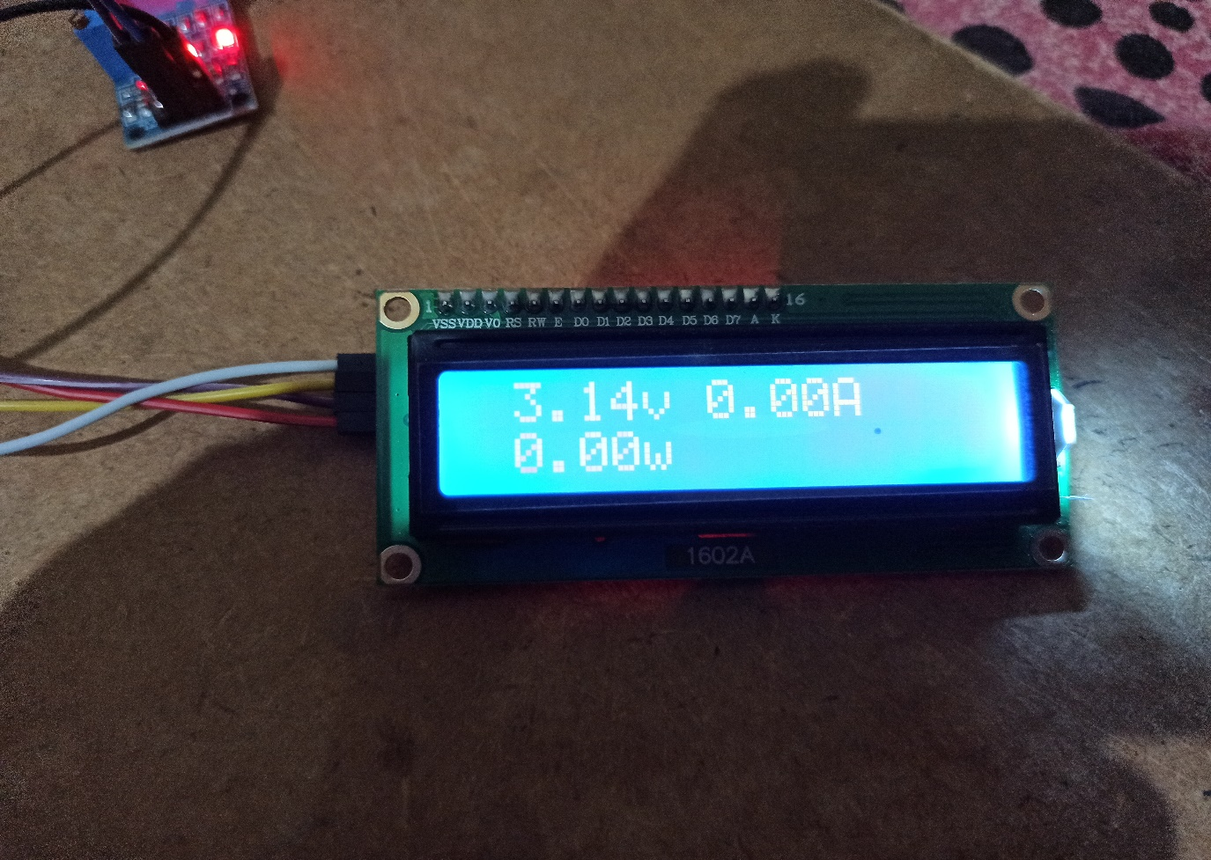

Fig.7.8. “Voltage,current and power displayed on LCD module”

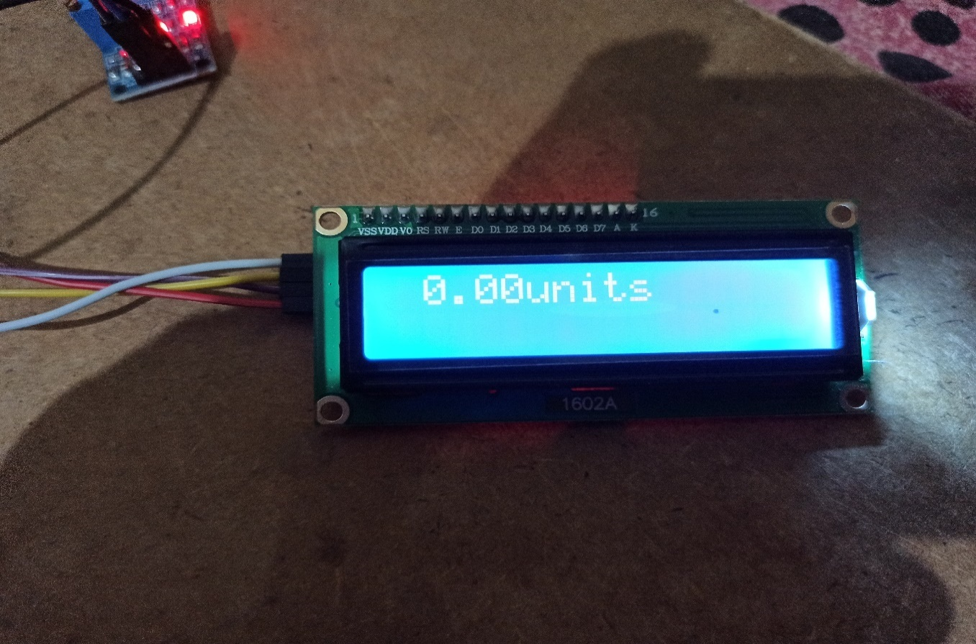

Fig.7.9. “Units displayed on LCD module”

* 1. **Discussion**

Quite significant results are obtained after checking the working of the system. The readings of the current and voltage sensor along with the consumed units and prices are obtained on the output screen of the Arduino IDE platform. Values were displayed on the 16 $×$ 2 LCD module. The cycle was repeated with a delay of 3 seconds. Graphical analysis of the data obtained is represented on the Thingspeak cloud storage platform sent over a Wi-Fi network.

Both of the features are worked over by the Wi-Fi network (ESP8266 module) and are aided in increasing the user-friendly ability of the device as of whole, the performance and working of the system are well monitored with proper significant output and also it aids in less power consumption with safety measures. Following figure shows the working energy meter setup

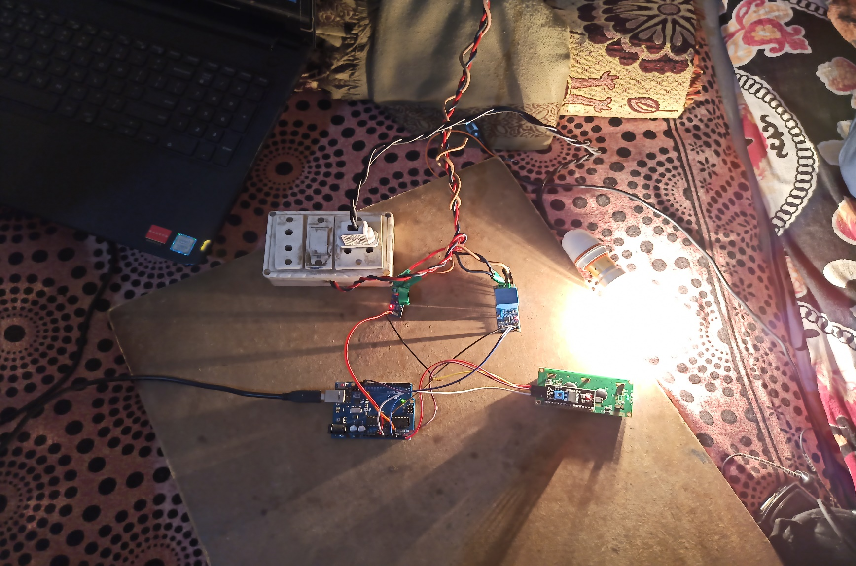

Fig. 7.10. “Smart Energy Meter Hardware”

* 1. **Bill of material**

|  |  |  |  |
| --- | --- | --- | --- |
| **S.N.** | **TYPES OF EXPENDITURE** | **SPECIFICATION** | **COST** |
| 1 | Microcontroller | Ardunio Mega | ₹550/- |
| 2 | Sensors | Voltage | ₹250/- |
| Current | ₹180/- |
| 3 | Wifi module | ESP8266-01 | ₹140/- |
| 4 | Electrical and wiring | Wires | ₹90/- |
| Light bulb | ₹15/- |
|  | Total cost |  | ₹1225/- |

Table 7.1. “Bill of components”

* 1. **Safety Measures**

1. Avoid water at all times when working with electricity. Never touch or try repairing any electrical equipment or circuits with wet hands. It increases the conductivity of the electric current.
2. Never use equipment with frayed cords, damaged insulation or broken plugs.
3. If you are working on any receptacle at your home then always turn off the mains. It is also a good idea to put up a sign on the service panel so that nobody turns the main switch ON by accident.
4. Always use insulated tools while working.
5. Always use appropriate insulated rubber gloves and goggles while working on any branch circuit or any other electrical circuit.
6. Know the wire code of our country.
   1. **Trouble Analysis: Causes and measures**

|  |  |  |  |
| --- | --- | --- | --- |
| S.N. | Trouble | Cause | Measure |
| 1 | Instantaneous Fluctuation in Voltage and Current | Supply variation | Calibrating sensors for every reading |
| 2 | Runtime of programme | Delay required for Wi-Fi module to upload | Making different functions for every task and looping them with conditions |

Table 7.2. “Trouble Analysis”

**CHAPTER VIII**

**PLANNING AND SCHEDULING**

|  |  |
| --- | --- |
| Task Name | Month |
| Finalization of Project | September |
| Literature Survey and Existing Systems Study | October |
| Requirement Analysis | October |
| Design and Modelling | November |
| For Project Phase 1, Basic Coding and Report | November |
| Coding and Implementation | December-February |
| testing | March |
| Experimental Results and Analysis | March |
| Research Paper development | March |
| Project Completion and Documentation | April |
| Final Project Report | May |

Table 8.1. “Planning and Scheduling”

**CHAPTER VIII**

**CONCLUSION AND RECOMMENDATION**

**9.1 Advantages**

1. This system also takes an automatic reading
2. Tackle of human error.
3. Power consumption devices control.
4. Easy connection without corruption.
5. Energy conversation.
6. Lots of time and power saving from power department.
7. To make consumer keep the track of energy meter.

**9.2 Limitations**

1. The calculation of the electric unit is on a time basis.
2. Sometime the system takes time to upload the data depending on the internet speed and module baud rate.
3. Verifying that the new meter is accurate.

**9.3 Conclusion**

The Arduino Mega 2560 based Energy Meter and Smart Home Appliance Monitoring System are built which is an energy-efficient system accomplishing two functions with a common microcontroller board. Also, the microcontroller used in this system allows more computer interfacing of other devices and is well connected over the ESP8266 Wi-Fi network. From the obtained results we get an overview of the working system proposed.

In future many more advanced features can be incorporated on the device as of consisting of the webserver by the electricity authorities for storing the data, taking necessary steps against electricity theft and also providing many more services in a convenient and faster way.

**9.4 Future Scope**

The developed smart meter can be very effectively used as one of the major components of a smart grid. In addition to being used for cyber security related studies, the developed device can have some immediate future advancement possible:

* System can be enhanced for power theft detection using IOT.
* The Android application can append options for online payment of bill.
* In the proposed method load analysis of single entity is performed; in future it can be boosted for area wise load analysis which will help for load forecasting.
* Prepayment can be added with model so as to develop pre-paid energy meters.

**REFERENCES**

[1] Bibek Kanti Barman, Shiv Nath Yadav, Shivam Kumar, Sadhan Gope, “IOT Based Smart Energy Meter for Efficient Energy Utilization in Smart Grid”, 2nd International conference on power,enery & environment,Pp.1-4, Jan 2018 India.

[2]Prathik.M, Anitha.K, Anitha.V*, “*Smart Energy Meter Surveillance Using IoT”, International Conference on Power, Energy, Control and Transmission Systems(ICPECTS 2018), Pp.186-189,22 – 23 February 2018, Chennai India.

[3] Himanshu K. Patel, TanishMody, Anshul Goyal, “Arduino Based Smart Energy Meter using GSM”, [2019 4th International Conference on Internet of Things: Smart Innovation and Usages (IoT-SIU)](https://ieeexplore.ieee.org/xpl/conhome/8767165/proceeding), Pp.1-6, 18-19 April 2019, Ghaziabad, India

[4] Sri Krishna Sankalp Gunturi, “IoT based Domestic Energy Monitoring Device”, 3rd International Conference for Convergence in Technology (I2CT),Pp.1-4, Apr 06-08, 2018, Pune, India

[5] Karthikeyan S, Bhuvaneswari P.T.V, “IoT Based Real-Time Residential Energy Meter Monitoring System” [Trends in Industrial Measurement and Automation (TIMA)](https://ieeexplore.ieee.org/xpl/conhome/8057694/proceeding) Pp.1-5, 6-8 Jan. 2017, Chennai, India

[6] Rahul Rajesh B, Mohan Kumar S, Nayab Z Shareif, Sourabh Kothari, K Ezhilarasan, “IoT Based Automatic Energing Sysyem with Prepaid/Postpaid Configurability”, International Conference On Smart Technology For Smart Nation,Pp.592-595, Jan 2017.Chennai,India

[7] Saikat Saha, Swagata Mondal, Anindya Saha, P. Purkait, “Design and Implementation of IoT Based Smart Energy Meter”, Proceedings of 2018 IEEE Applied Signal Processing Conference (ASPCON), Pp-19-23, Kolkata,India

[8] Jai Krishna Mishra, Shreya Goyal, Vinay Anand Tikkiwal, Arun Kumar, “An IoT Based Smart Energy Management System”, 4th International Conference on Computing Communication and Automation (ICCCA), Pp.1-4, 14-15 Dec 2018, Noida, India

[9] Osmi Jaiswal, Dilip Chaubisa, “Arduino Mega and IOT based Intelligent Energy Meter (IEM) to Increase Efficiency and Accuracy in Current Billing Methodology”, International Conference on Energy, Communication, Data Analytics and Soft Computing, Pp.1902-1904, 1-2 Aug 2017, Chennai, India

[10] Nazmat Toyin Surajudeen-Bakinde, Sunday Olufenka Ayodele, Timilehin David Oloruntoba,

Abdulrahaman Okino Otuoze, Nasir Faruk, “Development of an Internet Based Prepaid Energy Meter”, IEEE Africon Preceedings, Pp.1370-1373, 18-20 Sept 2017, Cape Town, South Africa

[11] Win Hlaing, Somchai Thepphaeng, Varunyou Nontaboot, Natthanan Tangsunantham, Tanayoot Sangsuwan,

Chaiyod Pira, “Implementation of WiFi-Based Single Phase Smart Meter for Internet of Things (IoT)”, 5th International Electrical Engineering Congress, Pp.1-4, 8-10 March 2017, Pattaya, Thailand

[12] Reni Clenitiaa.F, Ilakya.E, Preetha.G.S, Dr.B.Meenakshi, “Enhanced Digital Energy Meter”, International Conference on Computation of Power,Energy, Information and Communication (ICCPEIC), Pp.588-591, 22-23 March 2017, Melmaruvathur, India

[13] Md. Jakaria Islam Mozumder, Surojit Ghosh, “IoT Based Automatic Electricity Monitoring and

Remote Load Control System using PIC18F4550”, 9th ICCCNT, Pp.1-4, July 10-12, 2018, IISC, Bengaluru, India.

[14] Visalatchi S, Kamal Sandeep K, “Smart Energy Metering and Power Theft Control

using Arduino & GSM”, 2nd International Conference for Convergence in Technology (I2CT), Pp.858-861, 7-9 April 2017, Mumbai, India.

[15] Worrajak Muangjai, Phiched Thanin,

Wichan Jantee, Montri Ngaodet, Narong Nantakusol, “An Apply IoT for Collection and Analysis of Specific Energy Consumption in Production Line of Ready-to-Drink Juice at the Second Royal Factory Mae Chan” ***,***ICUE 2018 on Green Energy for Sustainable Development, Pp.1-4, 24 – 26 October 2018, Phuket, Thailand.

[16] Enrique Rodriguez-Diaz, Emilio J. Palacios-Garcia, Mehdi Savaghebi, Juan C. Vasquez, Josep M. Guerrero, “Advanced Smart Metering Infrastructure for Future Smart Homes”, IEEE 5th International Conference on Consumer Electronics Berlin (ICCE-Berlin),Pp.1-3, 12-13 Nov 2015, Berlin.

[17] Nikesh Man Shakya, Mehdi Mani, Noel Crespi, “SEEOF: Smart Energy Efficient Objective Function Adapting RPL Objective Function to enable an IPv6 Meshed Topology Solution for Battery Operated Smart Meters”, Pp.1-6,5-6 July, France.

[18] K. S. K. Weranga, D. P. Chandima, S. P. Kumarawadu, “Smart Metering for Next Generation Energy Efficiency & Conservation”, IEEE PES ISGT ASIA, Pp.1-8, Dec 2012, SriLanka.

[19] Mohammad Hossein Yaghmaee, Hossein Hejazi, “Design and Implementation of an Internet of Things Based Smart Energy Metering”, 6th IEEE International Conference on Smart Energy Grid Engineering, Pp.191-194, 12-15 Aug 2018, Oshawa, ON, Canada

[20] Ye Yuan, Kebin Jia, “A Distributed Anomaly Detection Method Of Operation Energy Consumption using Smart Meter Data”,International Conference on Intelligence Information Hiding & Multimedia Signal Processing, Pp. 310-313, 15-16 Feb 2015, Beijing, China.

[21] http://matrix.dte.us.es/grupotais/images/articulos/berhanu_itrevolutions.pdf [Accessed: 2012-11-12]